**Total Performance Monitoring**

Automatic Machine Learning and Root Cause Diagnosis

**Team Members**

|  |  |  |  |
| --- | --- | --- | --- |
| **Name** | **Email** | **Phone** | **Role** |
|  |  |  |  |
|  |  |  |  |
|  |  |  |  |
|  |  |  |  |

**Document Information and Approvals**

**Signoffs**

|  |  |  |  |
| --- | --- | --- | --- |
| **Phase** | **Name** | **Date** | **Signature** |
| Functional Specifications | Ramesh S Raj | 06/06/2014 |  |
|  |  |  |  |

**Revision History**

|  |  |  |
| --- | --- | --- |
| **Date** | **Reason for change(s)** | **Author(s)** |
| 06/06/2014 | Draft | Ramesh S Raj |
| 08/12/2014 | Reviewed & Updated | Akanksha Singh |

1. Introduction

Moseas Enterprise is a total performance management solution that provides automated IT monitoring, diagnosis, and reporting to troubleshoot application slowdowns, user experience issues, network outages, virtualization bottlenecks, server failures, storage hotspots, and more.

It uses a combination of agent-based and agentless approach to monitor the health and performance of the entire IT infrastructure from application code to bare metal across physical and virtual environments – from a single pane of glass*.

Features of an effective single pane of glass dashboard include:

- An intuitive graphical user interface (GUI) that is thoughtfully laid-out and easy to navigate.

- A logical structure behind the display that makes accessing current data easy and fast.

- A display that can be customized and categorized to meet the end user’s specific needs.

1. Purpose

* This tools keeps track of all the requests submitted to the system.
* Simplify and Monitor the process of Backup and Recovery.
* Tools to evaluate and analyse the performance related issues.
* Monitor ongoing Backups and restore.

1. Functionality

The solution should be based on client server Architecture, for data input, viewing and reporting. This tool creates backups only for the specific DB related entities (data, files, tables), so this tool doesn’t replace a tool that backups the entire system.

This tool can be used to restore the backups to specific databases.

The tool is intended for the use of database admin users, since they are the ones that can do system wide changes in the application, like create, customize, install modules and so on.

1. System Architecture

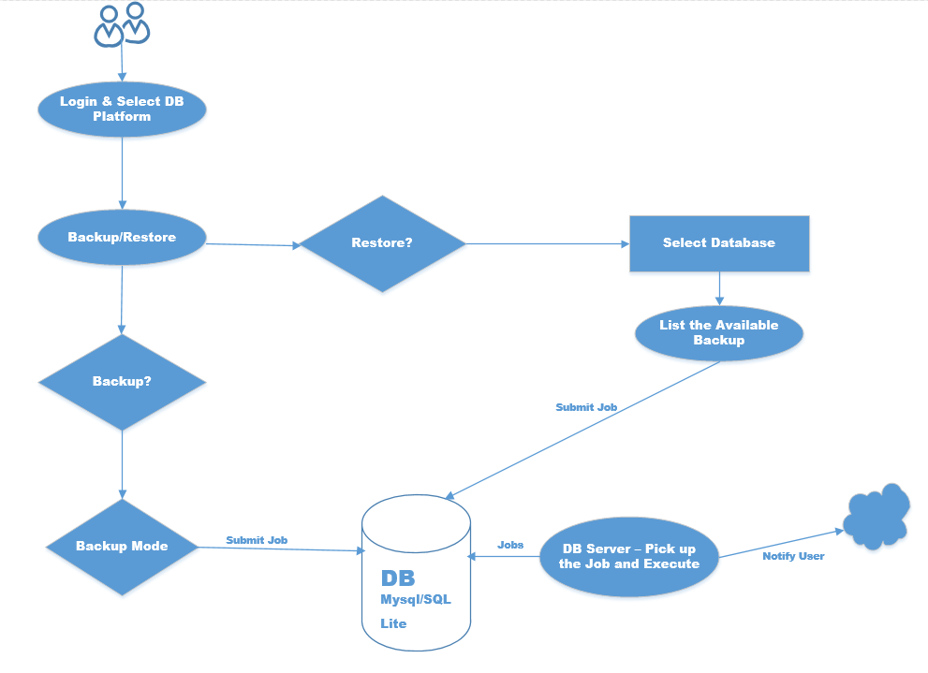

1. Usage of the Tool

The primary use of the Database Backup and Restore tools is to give the DBA’s a one-stop Administrative experience. The DBA will be able to schedule jobs remotely without actually logging to the Server. This Tool will accomplish the following:

* Authentication based on access.
* Ability to Schedule recurring Backups.
* Ability to restore.
* Ability to deploy DB related script to each server. (Phase II)
* Scripts in the server to poll the database for any job and execute the same on time.
* Ability to Track users who executed the backup.
* Ability to self-tune (improve performance) based on the system resource.(Phase II)
* Ability to Monitor the Backup, online/offline.
* Ability to Schedule Multiple Backup methodologies.
* Ability to Support Multiple Versions of DB.
* Ability to capture error in case backup/restore fails and alert the user.
* Ability to send email alerts once the backup/restore is completed.
* Ability to Monitor the backup and restore time lines.
* Generate report of History data.
* Ability to check the backup before restoring.

1. Login Flow

When DBA log into the application, the security layer will determine their user level (administrator, access privilege) and what database platform they can use.



1. Functional Specification

Different Types of Backups/Restore based on different database platform, which the tools can perform are:

**Oracle**

* Ability to perform cold backup/restore.
* Ability to perform hot backup/restore.
* Ability to perform RMAN backup/restore.
* Ability to perform table level backup.
* Ability to perform Tablespace level backup.
* Ability to perform Incremental backup.
* Export and Import.
* Monitor Alert Log

**MYSQL**

* Ability to perform Export and Import
* Ability to Perform Cold backup.
* Ability to perform Host backup.
* Ability to perform snapshot backups.
* Ability to perform Incremental backups.
* Ability to perform PITR.
* Using mysqldump or mysqlhotcopy.

**PostgreSQL**

* Ability to Perform File Level Backup
* Ability to perform Hotbackup.
* Logical backup using pg_dump
* Ability to perform Table level Backup.
* Ability to perform PITR.
* Ability to Monitor Backup and Restore.
* Ability to Restore.

**MSSQL**

.

* Ability to perform [Full backups](http://www.mssqltips.com/tutorial.asp?tutorial=7).
* Ability to perform [Differential backups.](http://www.mssqltips.com/tutorial.asp?tutorial=9)
* Ability to perform [Partial backups](http://www.mssqltips.com/tutorial.asp?tutorial=27).
* Ability to perform copy-Only backups.
* Ability to perform Mirror backups.
* Ability to perform [Transaction log backups](http://www.mssqltips.com/tutorial.asp?tutorial=8).

1. Performance Monitoring

Irrespective of the database technology, the tool will accommodate the following functionality:

* Database Performance Monitoring
* Index Monitoring
* Database Audit
* Intelligent database/table Vacuuming
* Query Analysis/Recommendation.
* Log Analysis
* Automated Alert Monitoring

1. Server Monitoring

Server/Storage Monitor enables us to monitor and measure critical metrics like CPU, memory, disk utilization, processes and network traffic of Linux servers from a unified dashboard.

* Load Average
* System Busy/Idle Time
* CPU - CPU utilization by cores, interrupts and context switches, average CPU usage (%)
* Process Statistics - a quick look on the running processes and blocked processes in your Linux server.
* System Idle Percentage - This gives the percentage of system/server spent in the idle state.
* Memory - Memory break up, memory pages (In/Out/Fault), swap/free memory utilization. Monitoring memory usage helps you to identify under used servers and redistribute loads effectively. This helps to detect server overloads before they cause a downtime or data loss.
* Disk Utilization - Disk partition, average/current individual disk usage, disk (I/O). Site24x7 Linux server monitoring helps you to closely monitor disk usage and update you with the availability of disk space in your servers.
* System Stats - Login count, total services/processes running
* Asset Details (Audit) - Host name, IP address, OS type, number of CPU cores
* Automated Alert Monitoring

1. Network Monitoring

Simple approach to oversee an entire network infrastructure

* Automatically Network Discovery and Scanning for Wired and Wifi Computers and Devices
* Easy to Use Performance Dashboard to Analyze Critical Data points and paths across your network
* Automatically Network Map and Topology Views
* Manage, Monitor and Analyze Wifi Networks within the Dashboard
* Create HeatMaps of Wifi Networks to pin-point Wifi Dead Spots
* Monitor Hardware Health of all Servers, Firewalls, Routers, Switches, Desktops, laptops and more.
* Real-Time Network and Netflow Monitoring for Critical Network Components and Devices

**Technology/Programming Language**

**Phase -I**

**Programming Language**: Python

**Database**: MYSQL/SQL Lite

**Scripting**: Perl and Unix/Linux Scripting.

**Phase-II**

**Programming Language**: Python/Php

**Database**: MYSQL/SQL Lite

**Scripting**: Perl and Unix/Linux Scripting.